CST116

Module 9: Project 3 pp 294-295 10.15 Programming Exercise #4 4 functions are defined.

Submit:

10 pts: Flow-chart and/or pseudocode
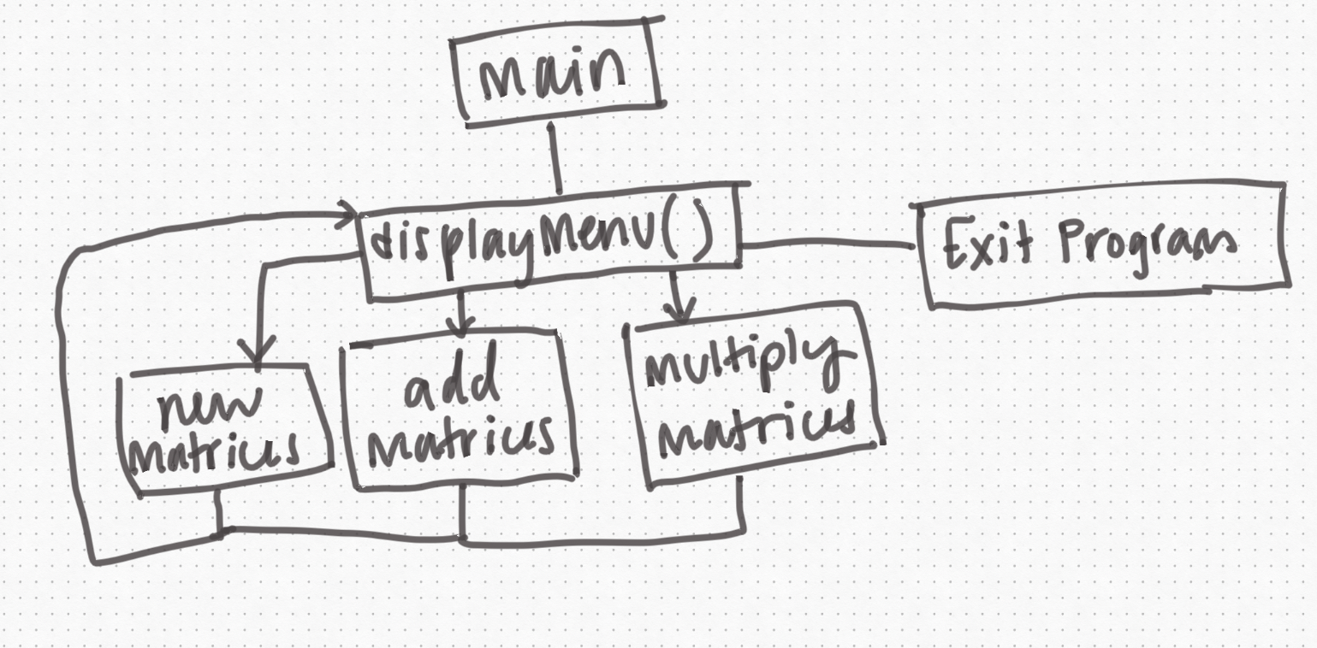
using namespace std;

establish void displayMenu, enterMatrix, multiplyMatrices, addMatrices functions.

int main()
int matrixOne[3][3];
int matrixTwo[3][3];
int matrixThree[3][3];
call displayMenu(matrixOne, matrixTwo, matrixThree) function

return 0;

void displayMenu(matrixOne, matrixTwo, matrixThree) calls a function based on the choice entered by the user
switch statement
case 1: get new matrices
call enterMatrix function
case 2: multiply matrices
call multiplyMatrices function
case 3: Add matrices
call addMatrices function
case 4: exit program
print thank you message

void enterMatrix(matrixOne, matrixTwo)
cout "enter 9 numbers you'd like to be in your first matrix. Press enter after each number."

for (int a = 0; a < 9; a++)
cout >> "\nenter number here: ";
if a < 3
cin << matrixOne[0][a]
else if a < 6
cin << matrixOne[1][(a - 3)]
else if a < 9
cin << matrixOne[2][(a - 6)]

cout "now enter the 9 numbers for your second matrix. Again, enter after each number."

for (int a = 0; a < 9; a++)
cout >> "\nenter number here: ";
if a < 3
cin << matrixTwo[0][a]
else if a < 6
cin << matrixTwo[1][a - 3]
else if a < 9
cin << matrixTwo[2][a - 6]

call displayMenu(matrixOne, matrixTwo, matrixThree)

void addMatrices(matrixOne, matrixTwo, matrixThree)
//Jericho’s section

void multiplyMatrices(matrixOne, matrixTwo, matrixThree)
//Jericho’s section

10 pts: Documentation (be sure to include your name and contact information in your documentation)
Cari Blaker, (602) 350-8743
Jericho (541) 217-7211
Jericho to focus on addition and multiplication of matrices, I am to focus on menu, exit, entering matrices, and formatting.

20 Testing plan & runs
We want to come up with our own testing plans, and be sure to let each other know how the testing went and what we tested to make sure we’re covering all our bases.
I plan to make sure to use negative numbers, zeros, single, double, and three digit numbers.
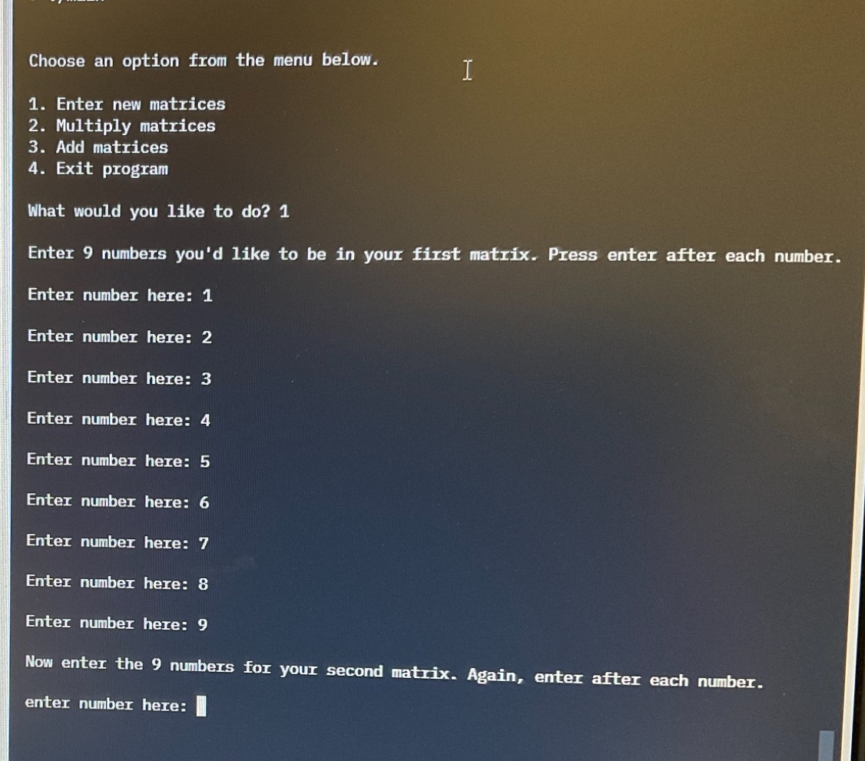
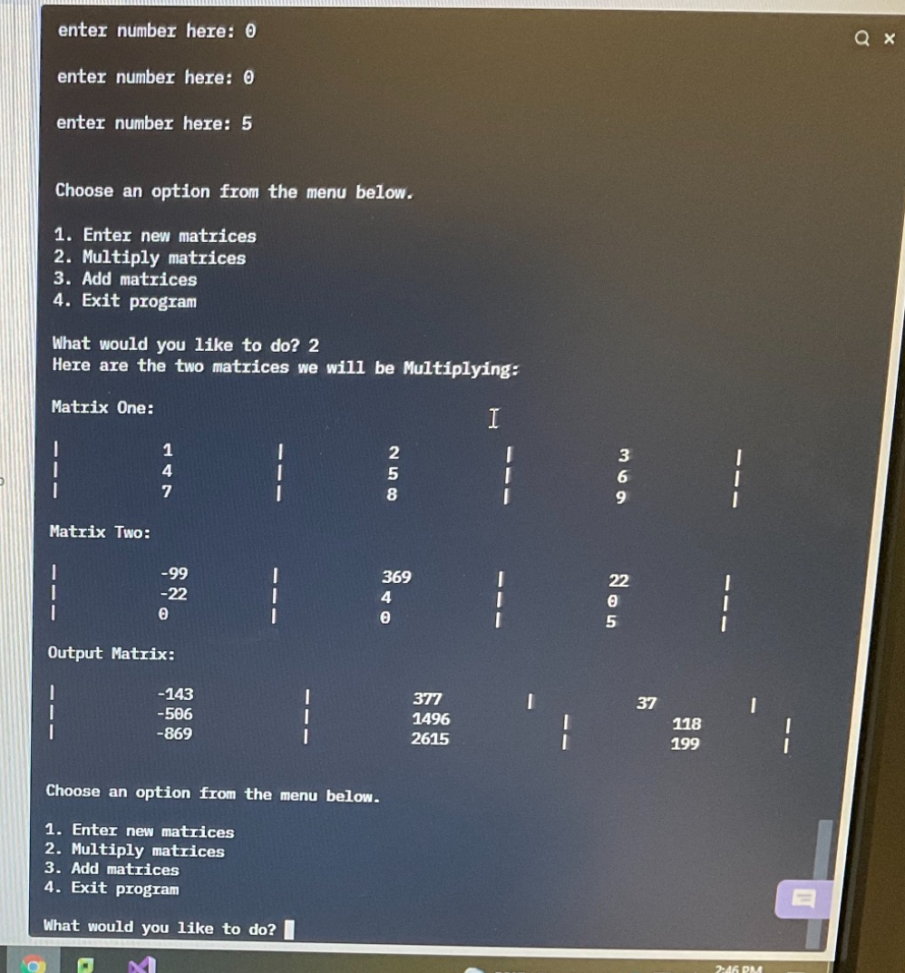

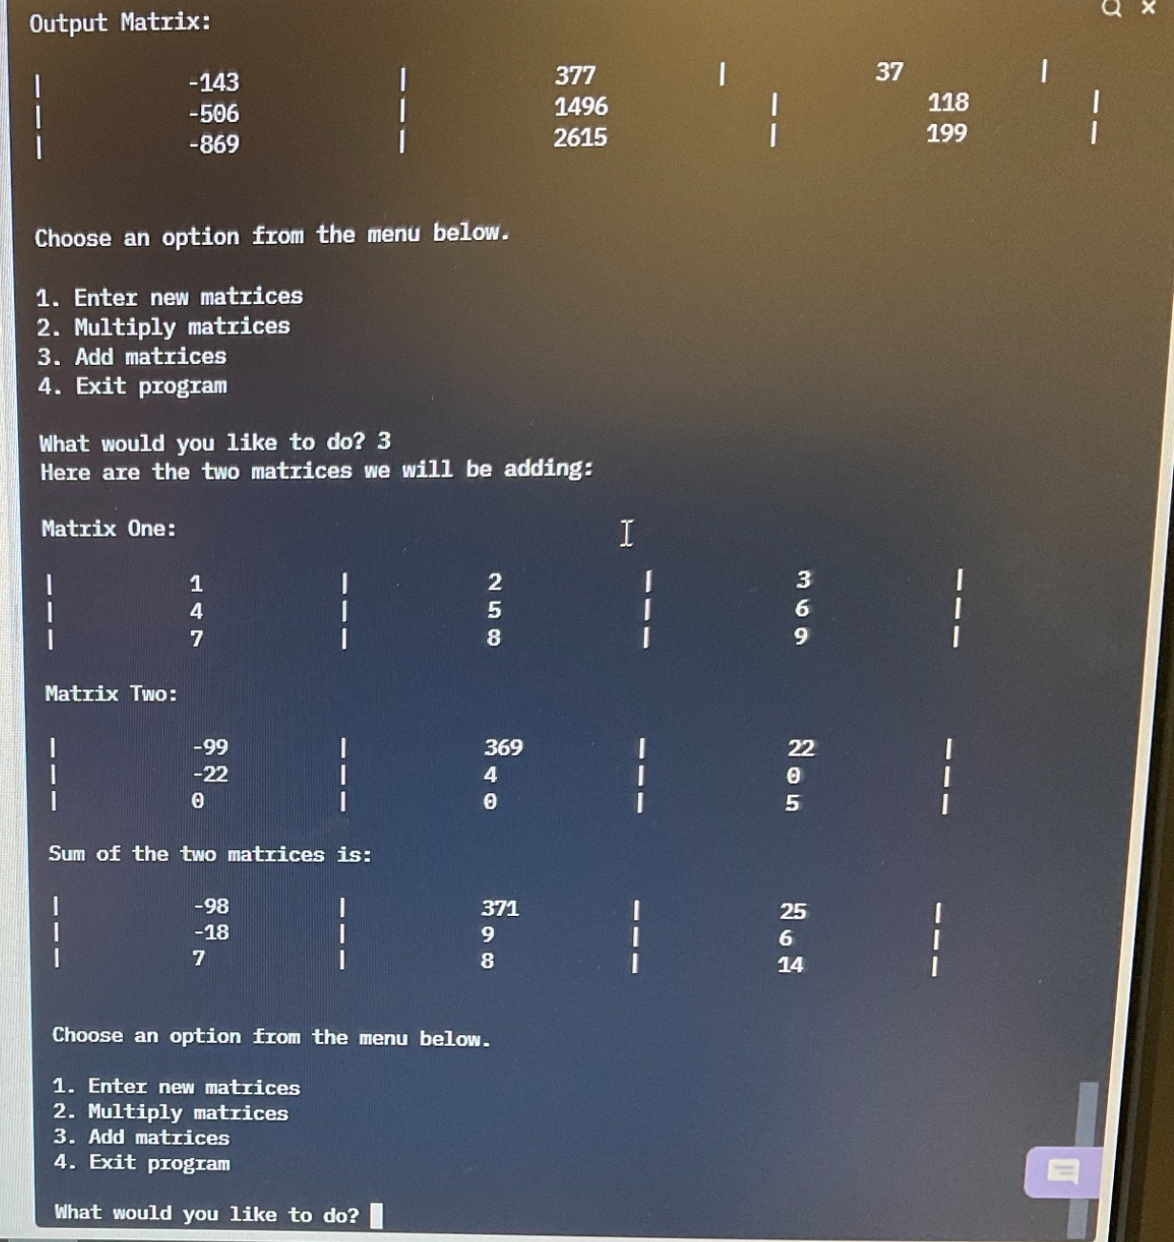

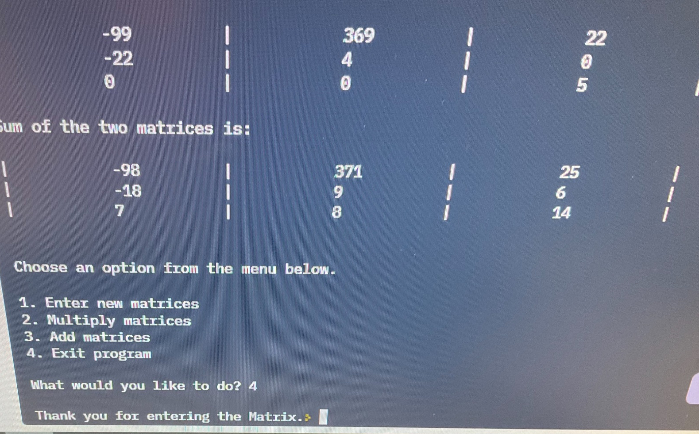

50 pts: Code

#include <iostream>

using namespace std;

void displayMenu(int[3][3], int[3][3]);
void enterMatrix(int[3][3], int[3][3]);
void multiplyMatrices(int[3][3], int[3][3]);
void addMatrices(int[3][3], int[3][3]);

int main() {
int matrixOne[3][3];
int matrixTwo[3][3];
int matrixThree[3][3];

displayMenu(matrixOne, matrixTwo);

return 0;

}

void displayMenu(int matrixOne[3][3], int matrixTwo[3][3]) {
int menuOption;

cout << "\n\nChoose an option from the menu below.\n";
cout << "\n1. Enter new matrices";
cout << "\n2. Multiply matrices";
cout << "\n3. Add matrices";
cout << "\n4. Exit program";

cout << "\n\nWhat would you like to do? ";
cin >> menuOption;

switch (menuOption)
{
case 1:
enterMatrix(matrixOne, matrixTwo);
break;
case 2:
multiplyMatrices(matrixOne, matrixTwo);
break;
case 3:
addMatrices(matrixOne, matrixTwo);
break;
case 4:
cout << "\nThank you for entering the Matrix.";
break;
default:
cout << "\nPlease enter a valid menu option.\n";
displayMenu(matrixOne, matrixTwo);
break;
}
}

void enterMatrix(int matrixOne[3][3], int matrixTwo[3][3]) {

cout << "\nEnter 9 numbers you'd like to be in your first matrix. Press enter after each number.\n";

for (int a = 0; a < 9; a++) {

cout << "\nEnter number here: ";
if (a < 3)
cin >> matrixOne[0][a];
else if (a < 6) {
int b = a - 3;
cin >> matrixOne[1][b];
}
else if (a < 9) {
int c = a - 6;
cin >> matrixOne[2][c];
}
}

cout << "\nNow enter the 9 numbers for your second matrix. Again, enter after each number.\n";

for (int a = 0; a < 9; a++) {
cout << "\nenter number here: ";
if (a < 3)
cin >> matrixTwo[0][a];
else if (a < 6) {
int b = a - 3;
cin >> matrixTwo[1][b];
}
else if (a < 9) {
int c = a - 6;
cin >> matrixTwo[2][c];
}
}

displayMenu(matrixOne, matrixTwo);
}

void addMatrices(int matrixOne[3][3], int matrixTwo[3][3]) {

cout << "Here are the two matrices we will be adding: ";

cout << "\n\nMatrix One: \n";
for (int r = 0; r < 3; r++) {
cout << "\n|\t\t\t";
for (int c = 0; c < 3; c++) {
cout << matrixOne[r][c] << "\t\t\t|\t\t\t";
}
}
cout << "\n\nMatrix Two: \n";
for (int r = 0; r < 3; r++) {
cout << "\n|\t\t\t";
for (int c = 0; c < 3; c++) {
cout << matrixTwo[r][c] << "\t\t\t|\t\t\t";
}
}

int matrixThree[3][3];

for (int i = 0; i < 3; ++i)
for (int j = 0; j < 3; ++j)
matrixThree[i][j] = matrixOne[i][j] + matrixTwo[i][j];

cout << endl << "\nSum of the two matrices is:\n" << endl;
for (int i = 0; i < 3; ++i)
{
cout << "|\t\t\t";
for (int j = 0; j < 3; ++j)
{
cout << matrixThree[i][j] << "\t\t\t|\t\t\t";
if (j == 3 - 1)
cout << endl;
}
}
displayMenu(matrixOne, matrixTwo);
}

void multiplyMatrices(int matrixOne[3][3], int matrixTwo[3][3]) {

cout << "Here are the two matrices we will be Multiplying: ";
cout << "\n\nMatrix One: \n";
for (int r = 0; r < 3; r++) {
cout << "\n|\t\t\t";
for (int c = 0; c < 3; c++) {
cout << matrixOne[r][c] << "\t\t\t|\t\t\t";
}
}
cout << "\n\nMatrix Two: \n";
for (int r = 0; r < 3; r++) {
cout << "\n|\t\t\t";
for (int c = 0; c < 3; c++) {
cout << matrixTwo[r][c] << "\t\t\t|\t\t\t";
}
}

int matrixThree[3][3];

for (int i = 0; i < 3; ++i)
for (int j = 0; j < 3; ++j)
{
matrixThree[i][j] = 0;
}

for (int i = 0; i < 3; ++i)
for (int j = 0; j < 3; ++j)
for (int k = 0; k < 3; ++k)
{
matrixThree[i][j] += matrixOne[i][k] * matrixTwo[k][j];
}

cout << endl << "\nOutput Matrix:\n" << endl;
for (int i = 0; i < 3; ++i)
{
cout << "|\t\t\t";
for (int j = 0; j < 3; ++j)
{
cout << matrixThree[i][j] << "\t\t\t|\t\t\t";
if (j == 3 - 1)
cout << endl;
}
}
displayMenu(matrixOne, matrixTwo);
}

10 pts: Notes from your meetings: when you met and what you discussed
We decided we would use as much class time as possible, hopefully completing most of our code today in class, 11/30/21. Of course, we already had each other’s contact info from the last couple of projects.

12/5/21 We checked in with each other to see how it was going. I messaged Jericho on discord, since I felt I had completed my portion of the project on 11/30/21, but I wanted to make sure he felt like I had done a fair and adequate amount of work, that he didn’t need any more help, and that my code was satisfactory. He said I had done plenty and that he would get his part done soon!

12/7/21 Apparently Jericho sent me his completed code later that night on 12/5, and I didn’t see it until he mentioned it in class today. I looked it over, did a little more formatting modifications, and now I think it’s good to be turned in!

20 pts Individually: whenever you sit down to work on this project, record your “Agile” questions:

What SPECIFIC task will you complete in the next half hour?

What do you know about this SPECIFIC task?

What DON'T you know about this SPECIFIC task?

11/30/21

What SPECIFIC task will you complete in the next half hour? I will complete the pseudocode for the project!

What do you know about this SPECIFIC task? I know it will require at least three functions beyond main. I know one of them is a menu requiring a switch statement and the other two are math functions on matrices. I know each function will need to be passed three matrices.

What DON'T you know about this SPECIFIC task? I don’t know the best way to loop through matrices to perform math and put those new numbers into another matrix.

11/30/21, again, in class

What SPECIFIC task will you complete in the next half hour? I will get the displayMenu function running

What do you know about this SPECIFIC task? I know I will use a switch statement, and call other functions based on the menu choice. I will put dummy statements into the functions to make sure they’re being called correctly.

What DON'T you know about this SPECIFIC task? I don’t know what problems will arise. I don’t know if I should use separate functions for displaying the menu and processing the menu choice.

Again, at home on 11/30/21

What SPECIFIC task will you complete in the next half hour? I will get the enterMatrix function working,

What do you know about this SPECIFIC task? I know I need to use two for loops to iterate through the rows and columns of each matrix. I know I’ll need to display the matrices to make sure the entered info is getting into them correctly.

What DON'T you know about this SPECIFIC task? I don’t know how I’ll display them--which function, or what format. Or what formatting tools I’ll need to use to get a nice display.

12/7/21

What SPECIFIC task will you complete in the next half hour? I will fix the last of the formatting in the code.

What do you know about this SPECIFIC task? I know what’s wrong with it!

What DON'T you know about this SPECIFIC task? I’m not sure if adding more tabs will be able to fix it, or if I need to use printf formatting options and modify the entire code.

Total: 120 pts

