CST116
Module 7: Lab 7

12a
Write a program that includes a function to read (at least 100) strings into an array. Allow the user to either add a string or print out the contents of the array. Be sure to stop “printing” at the end of the entered values -- don’t “print” after the end of the user’s entered data. Be sure to give the user the chance to leave the program.
10 pts
Submit: code & runs

#include <iostream>
#include <string.h>
#include <stdio.h>
#include <iomanip>

using namespace std;

void ReadString(string[]);
void PrintString(int&, string[]);

int main() {
string entered_info[100]{};

ReadString(entered_info);
}

void ReadString(string entered_info[]) {

int j = 1;
int count = 0;

for (int i = 0; i <= j; i++) {

cout << "\n\nEnter the info you would like to store in the string, or STOP to stop, or PRINT to print what you've already entered: ";
getline(cin, entered_info[i]);
count++;
j++;
if ((entered_info[i] == "STOP") || (entered_info[i] == "Stop") || (entered_info[i] == "stop")) {
--j;
}

if ((entered_info[i] == "PRINT") || (entered_info[i] == "Print") || (entered_info[i] == "print")){
--j;
PrintString(count, entered_info);
}

}

}

void PrintString(int &count, string entered_info[]) {
for (int i = 0; i <= ( count - 2 ); i++) {
cout << entered_info[i] << "\n";
}
}
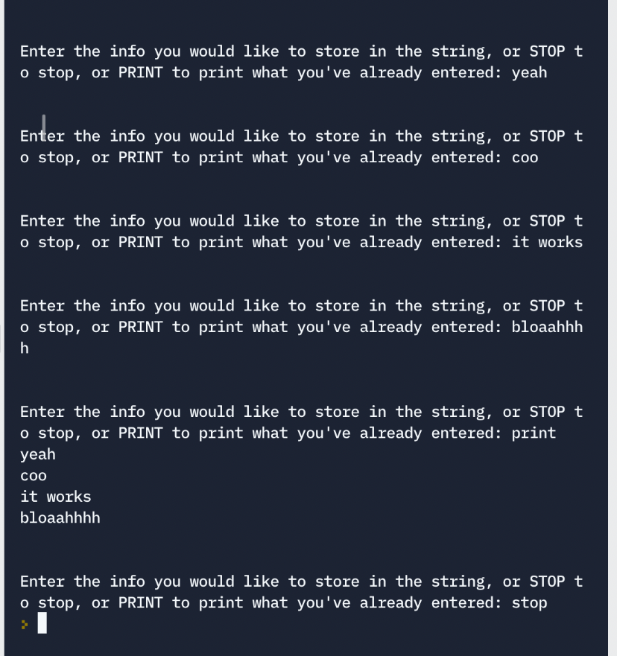

12b
Add to your program from part 12a:
An option in a function that can find a string or substring in a string in the array. This need just be the first occurrence of the string or substring.
10 pts
Submit: code & runs
#include <iostream>
#include <string.h>
#include <cstring>
#include <stdio.h>
#include <iomanip>

using namespace std;

void ReadString(string[]);
void PrintString(int&, string[]);
void SearchString(int&, string[]);

int main() {
string entered_info[100]{};
string search_info[100]{};

ReadString(entered_info);

}

void ReadString(string entered_info[]) {

int j = 1;
int count = 0;

for (int i = 0; i <= j; i++) {

cout << "\n\nEnter the info you would like to store in the string or enter STOP to stop, PRINT to print what you've already entered, SEARCH to search your previous entries, or DELETE to delete one of your previous entries: ";
getline(cin, entered_info[i]);
count++;
j++;
if ((entered_info[i] == "STOP") || (entered_info[i] == "Stop") || (entered_info[i] == "stop")) {
--j;
}

if ((entered_info[i] == "PRINT") || (entered_info[i] == "Print") || (entered_info[i] == "print")){
--j;
PrintString(count, entered_info);
}

if ((entered_info[i] == "SEARCH") || (entered_info[i] == "Search") || (entered_info[i] == "search")){
--j;
SearchString(count, entered_info);
}

}

}

void PrintString(int &count, string entered_info[]) {
for (int i = 0; i <= ( count - 2 ); i++) {
cout << entered_info[i] << "\n";
}
}

void SearchString(int &count, string entered_info[]){
int i = 0, j = 0, k = 0, correct = 0;
//i is letter in substring
//j is the word in the main array that we're testing
//k is the letter in the word in the main array

string search_info;

cout << "\nEnter the term you would like to search your entries for: ";
cin >> search_info;

for (j = 0; j < count; j++){
i = 0;
k = 0;
while ((search_info[i] != entered_info[j][k]) && (j < entered_info[j].size()))
k++;

if (search_info[i] == entered_info[j][k]){
while ( ( search_info == entered_info[j] ) && ( i < search_info.size() ) && (k < entered_info[j].size() ) ){
i++;
k++;
correct++;
}
}
}

if (correct == search_info.size())
cout << "\nSubstring " << search_info << " was found.";

else
cout << "\nSubstring " << search_info << " was not found.";
}
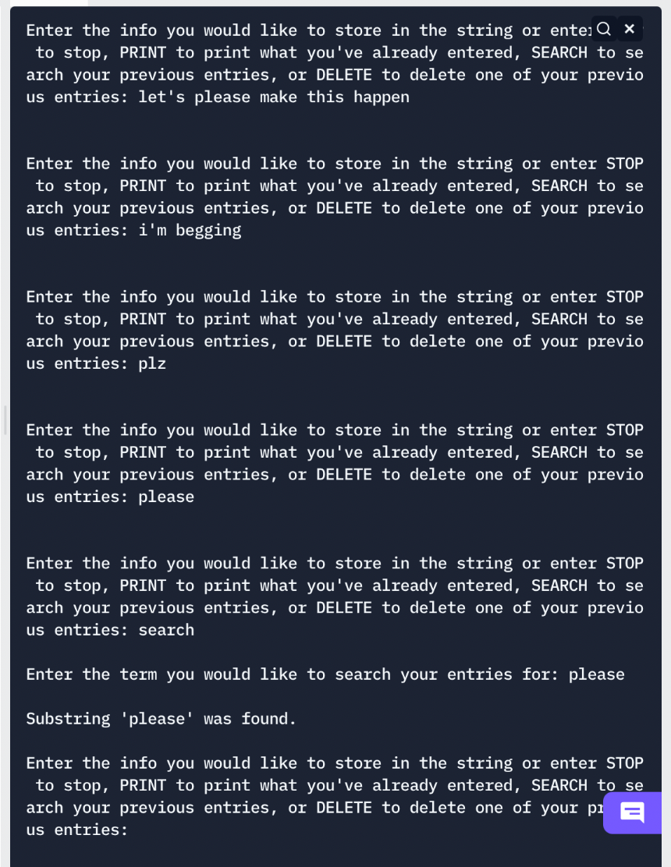

11c
Add to your program from part 12b:
An option in a function that can remove a string from the array (and compress the array) based on its location in the array. Make sure that the “print” option reflects the removed string.
10 pts
Submit: code & runs

#include <iomanip>

using namespace std;

void ReadString(string[]);
void PrintString(int&, string[]);
void SearchString(int&, string[]);
void DeleteString(int&, string[]);

int main() {
string entered_info[100]{};
string search_info[100]{};

ReadString(entered_info);

}

void ReadString(string entered_info[]) {

int j = 1;
int count = 0;

for (int i = 0; i <= j; i++) {

cout << "\n\nEnter the info you would like to store in the string or enter STOP to stop, PRINT to print what you've already entered, SEARCH to search your previous entries, or DELETE to delete one of your previous entries: ";
getline(cin, entered_info[i]);
count++;
j++;
if ((entered_info[i] == "STOP") || (entered_info[i] == "Stop") || (entered_info[i] == "stop")) {
--j;
}

if ((entered_info[i] == "PRINT") || (entered_info[i] == "Print") || (entered_info[i] == "print")){
--j;
entered_info[i] = "";
PrintString(count, entered_info);
}

if ((entered_info[i] == "SEARCH") || (entered_info[i] == "Search") || (entered_info[i] == "search")){
--j;
entered_info[i] = "";
SearchString(count, entered_info);
}
if ((entered_info[i] == "DELETE") || (entered_info[i] == "Delete") || entered_info[i] == "delete"){
--j;
entered_info[i] = "";
DeleteString(count, entered_info);
}
}

}

void PrintString(int &count, string entered_info[]) {
count--;
for (int i = 0; i < count; i++) {
cout << entered_info[i] << "\n";
}
}

void SearchString(int &count, string entered_info[]){
int i = 0, j = 0, k = 0, correct = 0;
//i is letter in substring
//j is the word in the main array that we're testing
//k is the letter in the word in the main array

string search_info;

cout << "\nEnter the term you would like to search your entries for: ";
cin >> search_info;

for (j = 0; j < count; j++){
i = 0;
k = 0;
while ((search_info[i] != entered_info[j][k]) && (j < entered_info[j].size()))
k++;

if (search_info[i] == entered_info[j][k]){
while ( ( search_info == entered_info[j] ) && ( i < search_info.size() ) && (k < entered_info[j].size() ) ){
i++;
k++;
correct++;
}
}
}

if (correct == search_info.size())
cout << "\nSubstring '" << search_info << "' was found.";

else
cout << "\nSubstring '" << search_info << "' was not found.";
}

void DeleteString(int & count, string entered_info[]){
int deletenumber = 0;

cout << "\nEnter the number of the entry you would like to delete: ";
cin >> deletenumber;
deletenumber--;

for (int i = deletenumber; i < count; i++)
entered_info[i] = entered_info[i + 1];

}

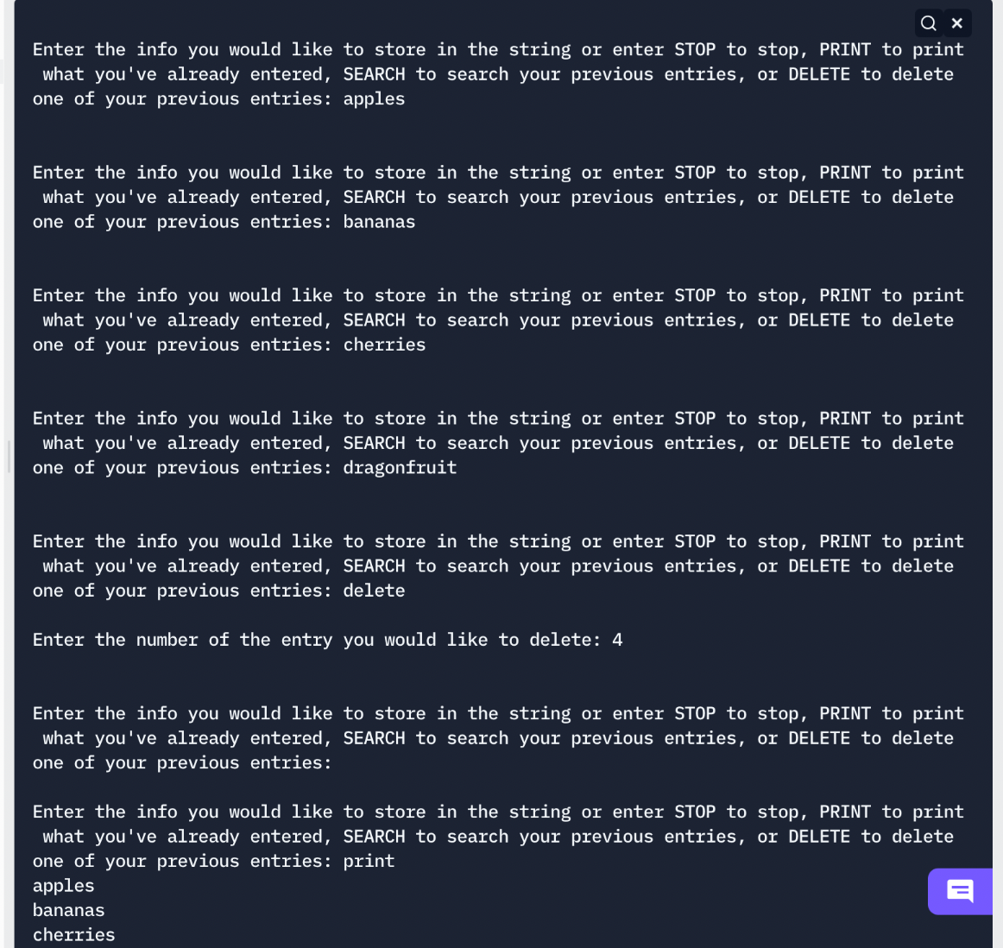

Total: 30 pts

