CST116

Module 6: Lab 6

11a 10.10 Learn by Doing Exercises pp 282-283 10 pts #1 Submit: code & runs

#include <iostream>
#include <cstring>
#include <iomanip>

using namespace std;

#define ARRAY_SIZE 10
void readData(string[ARRAY_SIZE][2], int[ARRAY_SIZE]);
void calcMoney(int[ARRAY_SIZE], int[ARRAY_SIZE]);
void displayData(string[ARRAY_SIZE][2], int[ARRAY_SIZE], int[ARRAY_SIZE]);

int main()
{
string stringInfo[ARRAY_SIZE][2]{};
int numStudents[ARRAY_SIZE]{};
int clubMoney[ARRAY_SIZE]{};

readData(stringInfo, numStudents);
calcMoney(numStudents, clubMoney);
displayData(stringInfo, numStudents, clubMoney);

}

void readData(string stringInfo[ARRAY_SIZE][2], int numStudents[ARRAY_SIZE])
{
int i = 0;
while ( i < ARRAY_SIZE )
{
cout << "Enter Student Club Name: ";
getline(cin >> std::ws,stringInfo[i][0]);
cout << "Enter Club President's Name: ";
getline(cin >> std::ws,stringInfo[i][1]);
cout << "Enter Club's number of students: ";
cin >> numStudents[i];
i++;
cout << endl;
}

// for ( int i = 0; i < ARRAY_SIZE; i++)
// {
// cout << "Enter Club President's Name: ";
// getline(cin >> std::ws,stringInfo[i][1]);
// cout << endl;
// }

cout << endl;
}

void calcMoney(int numStudents[ARRAY_SIZE], int clubMoney[ARRAY_SIZE]){

for (int i = 0; i < ARRAY_SIZE; i++){
clubMoney[i] = ( numStudents[i] * 75 );
}
}

void displayData(string stringInfo[ARRAY_SIZE][2], int numStudents[ARRAY_SIZE], int clubMoney[ARRAY_SIZE]){

if (true){

cout << setw(30) << left << "Student Club" << setw(30) << "President" << setw(20) << "Number of Students" << setw(20) << right << "Budget Allocation\n";
for(int i = 0; i < ARRAY_SIZE; i++){
cout << setw(30) << left << stringInfo[i][0] << setw(30) << stringInfo[i][1] << setw(30) << numStudents[i] << right << "$" << clubMoney[i];
cout << "\n";

}
}

}
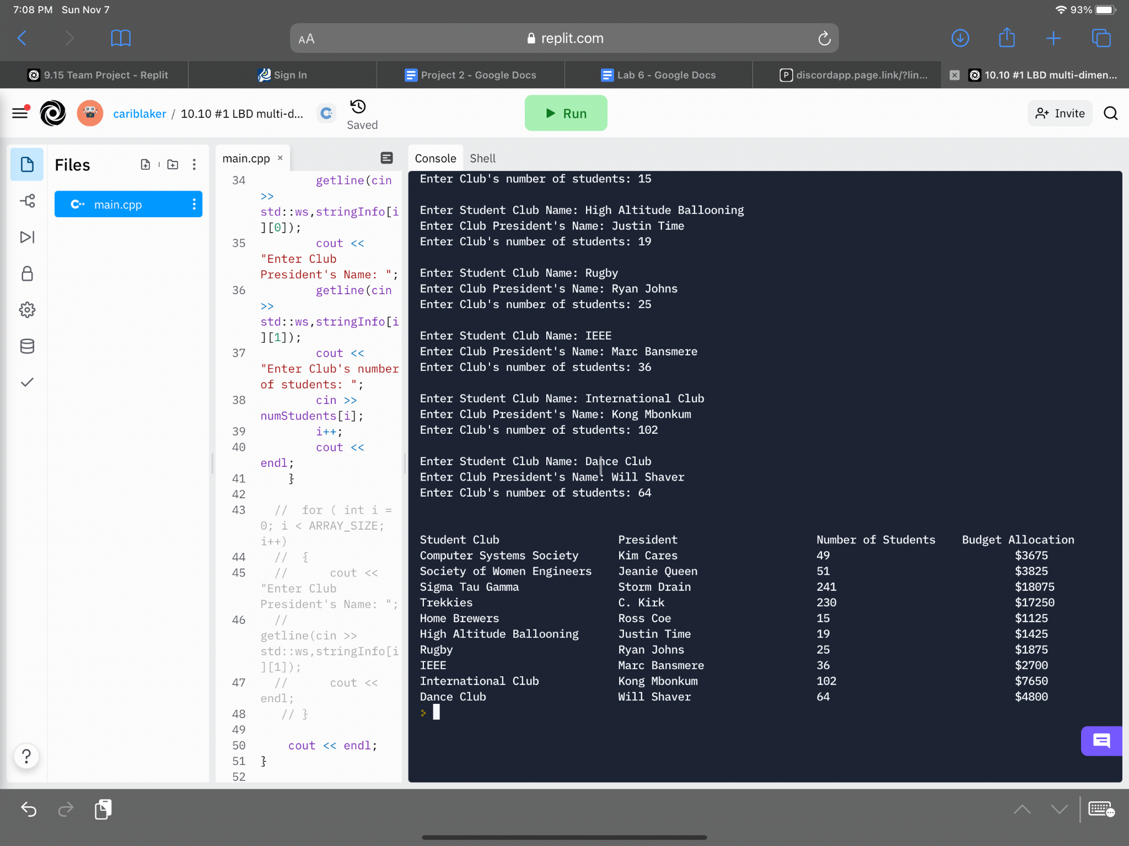

11b 10.14 Debugging Exercises pp 289-292 10 pts #1 Submit: code & runs

#include <iostream>
#include <iomanip>
using std::cin;
using std::cout;
using std::endl;
using std::setw;

void GetAndDisplayWelcomeInfo ( );
void FunctionOne ( int varX[], int varY[] );
void FunctionTwo ( int varX[], const int varY[], int varZ[] );
void PrintFunction ( int varX[], const int varY[],
const int varZ[] );

const int SIZE = 10;

int main ( )
{
int varX[SIZE];
int varY[SIZE];
int varZ[SIZE]; // Notice how we used the const here!

// Breakpoint 1
// Put breakpoint on the following line
GetAndDisplayWelcomeInfo ( );
FunctionOne ( varX, varY );

// Breakpoint 3
// Put breakpoint on the following line
FunctionTwo ( varX, varY, varZ );
varZ[0] = -99;
PrintFunction ( varX, varY, varZ );

return 0;
}
void GetAndDisplayWelcomeInfo ( )
{
char name[2][20]; // First name in row 0, last name in row 1

cout << "Please enter your first name: ";
cin >> name[0];

cout << "\nPlease enter your last name: ";
cin >> name[1];

// Breakpoint 2
// Put breakpoint on the following line
cout << "\n\n\tWelcome " << name[0] << " " << name[1]
<< "!\n\t Hope all is well \n\n";
}
void FunctionOne ( int varX[], int varY[] )
{
for ( int x = 0; x <= 8; x++ ) // NOTICE '<' NOT <=
// Breakpoint 4
// Put breakpoint on the following line
varX[x] = x;

for ( int x = 0; x < SIZE; x++ )
varY[x] = x + 100;
}
void FunctionTwo ( int varX[], const int varY[], int varZ[] )
{
for ( int x = 0; x < SIZE; x++ ) // Notice the const SIZE here
varZ[x] = varX[x] + varY[x];
varX[1] = 99;

}
void PrintFunction ( int varX[20], const int varY[20], const int varZ[20] )
{
int x;

cout << " \t x \t y \t z\n\n";

for ( x = 0; x < SIZE; x++ )
cout << "\t" << setw ( 3 ) << varX[x]
<< "\t " << varY[x]
<< "\t " << varZ[x] << endl;
}
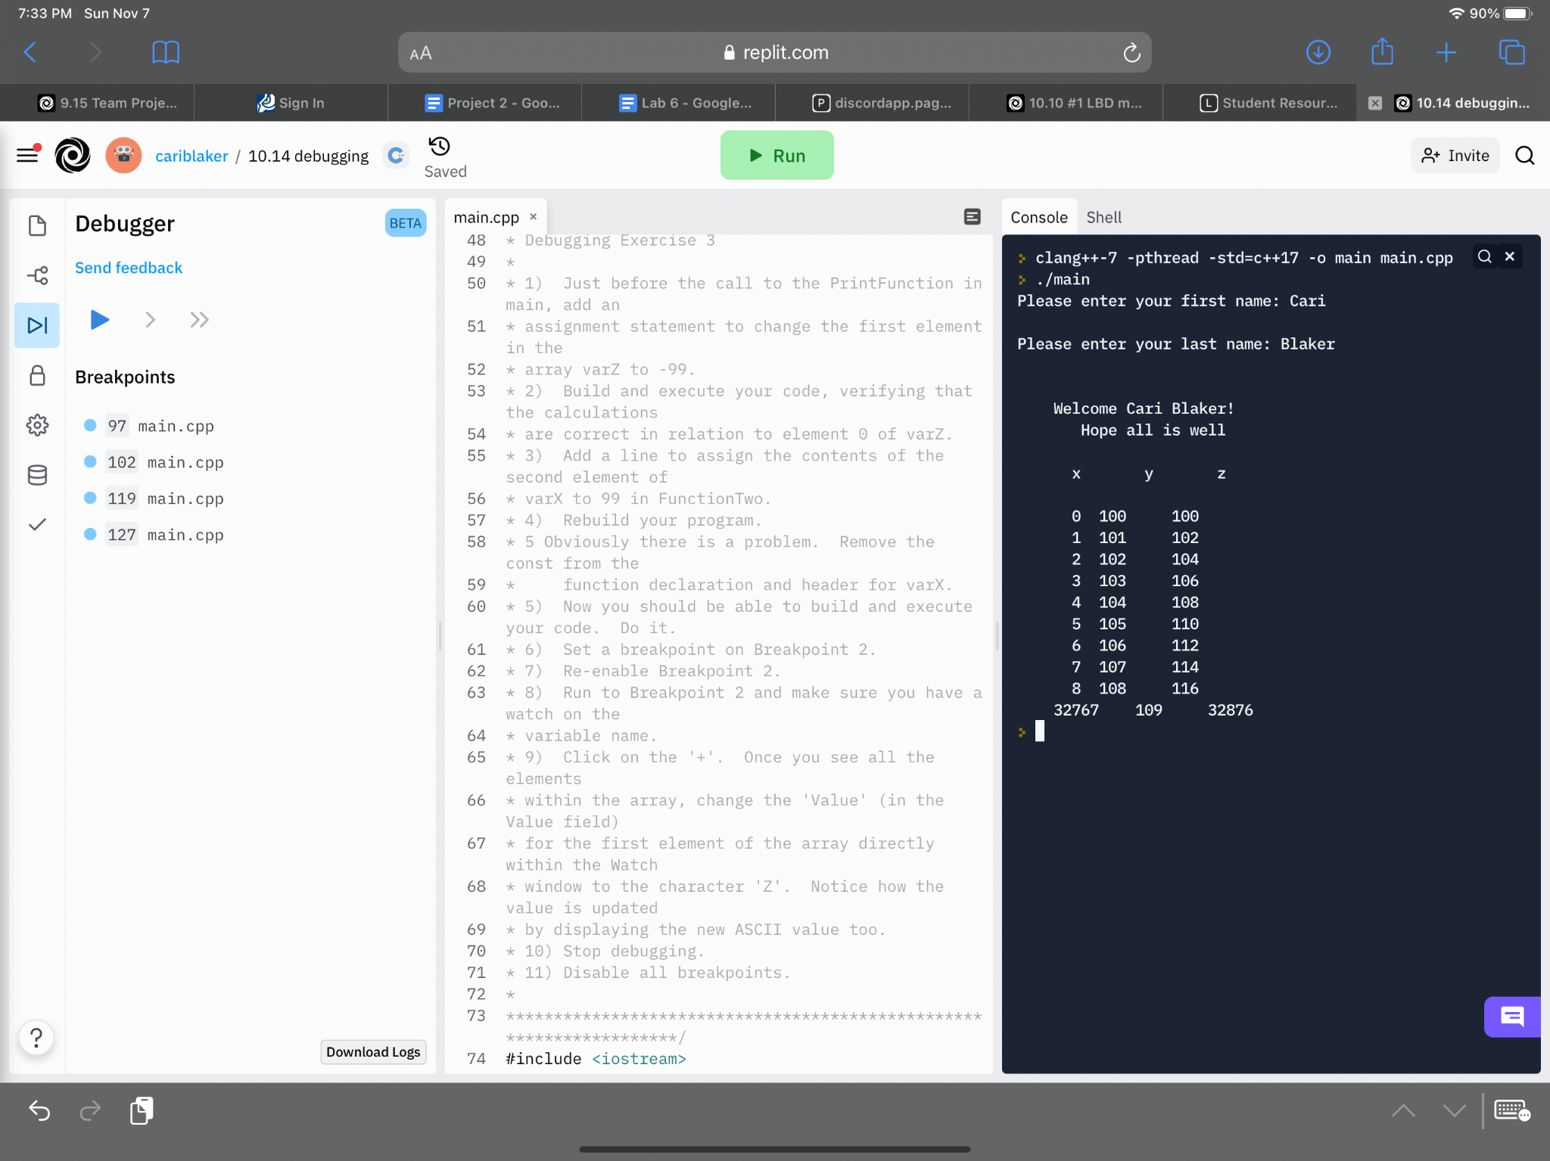
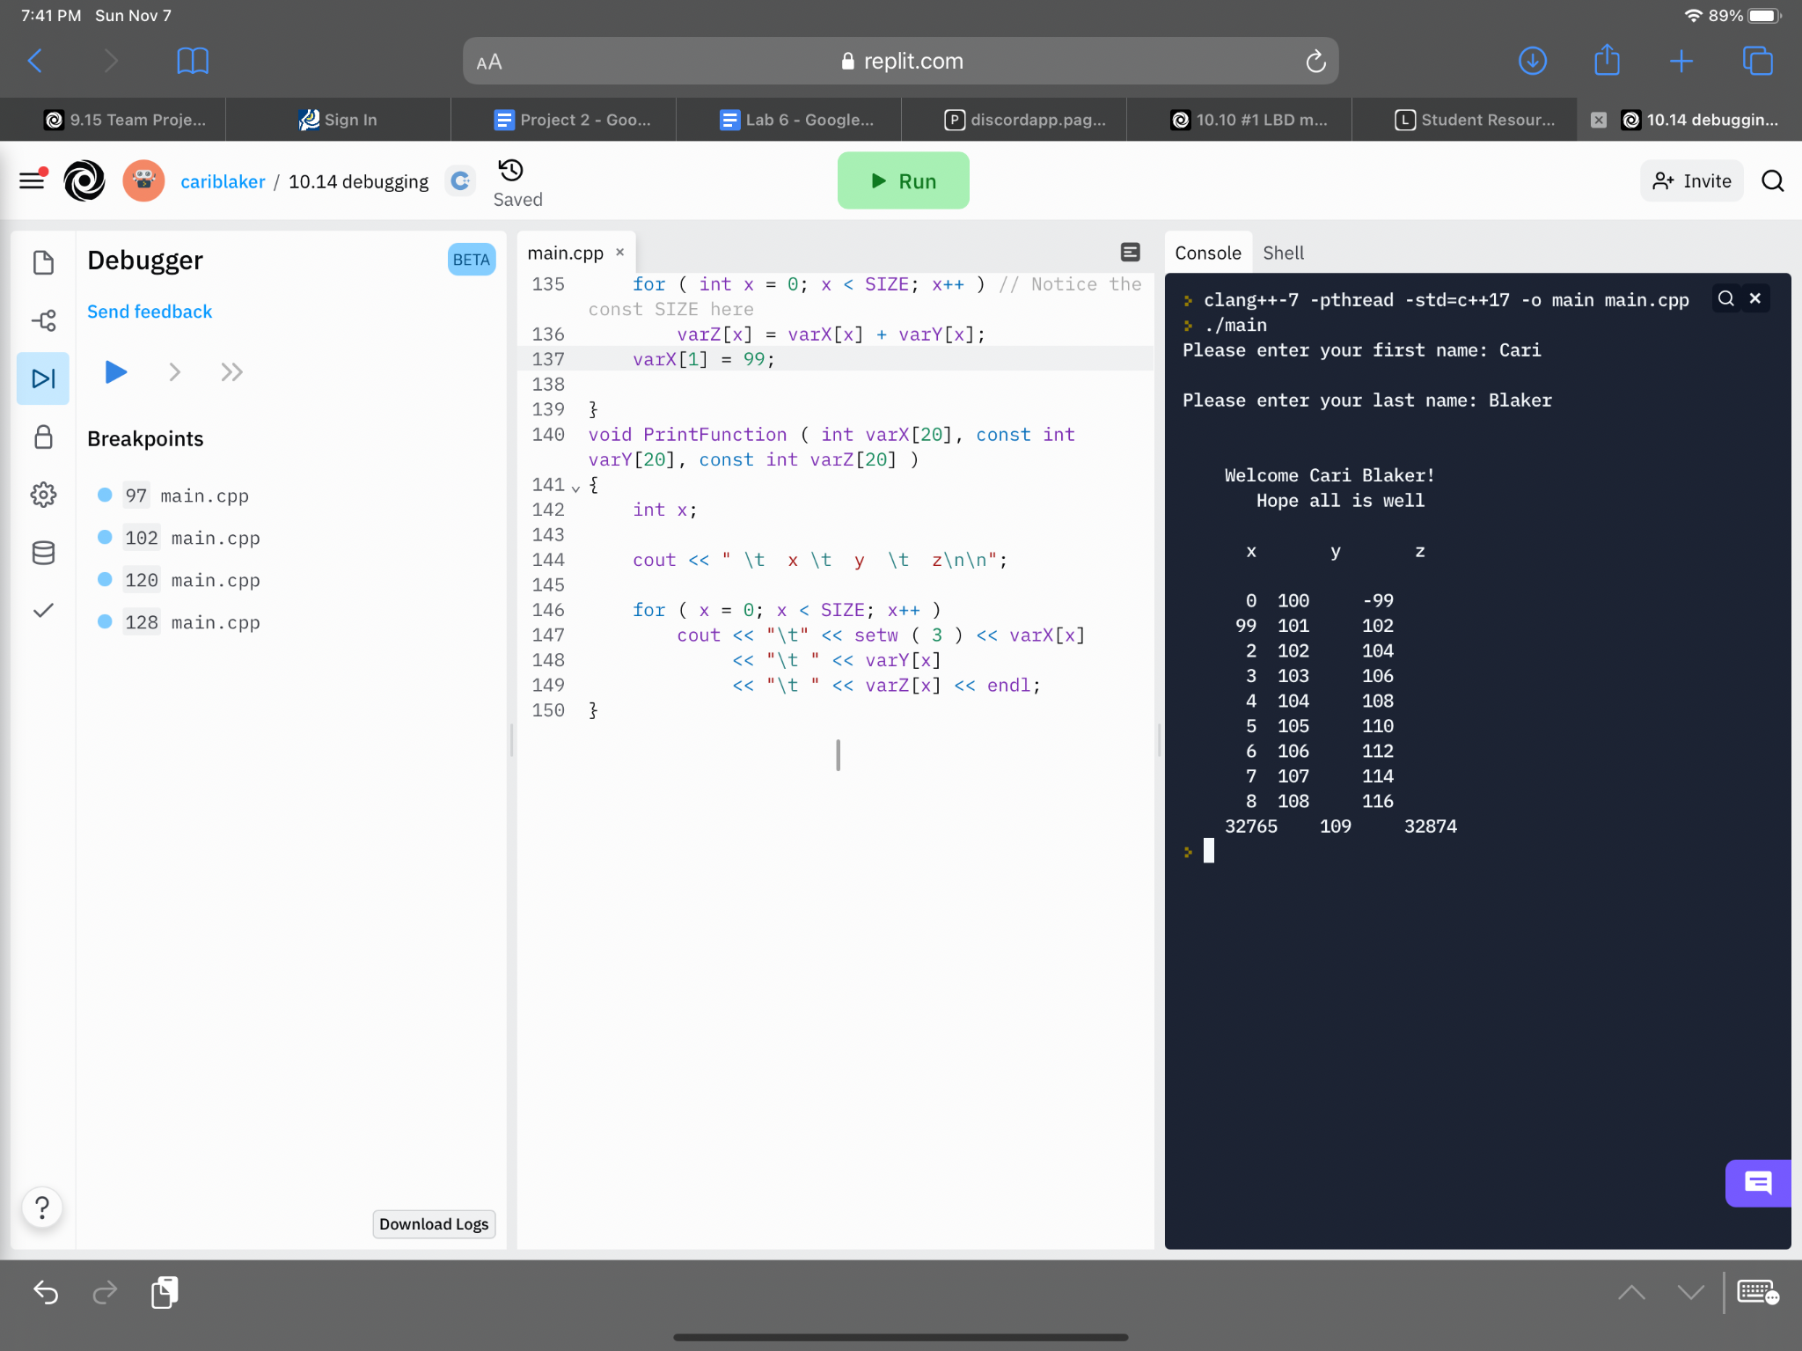

11c 10.15 Programming Exercises pp 292-293 10 pts #1 Submit: code & runs Total: 30 pts
#include <iostream>
#include <iomanip>
#include <cstring>
#include <string.h>

using namespace std;

bool isPalindrome(char[]);
bool isAlphaStr(char[]);
int countChar(char[], char);

int main() {

char word[50]{};
char letter;

cout << "\nWelcome to the word checker program!\n";
cout << "\nGo ahead and enter the word you'd like to check: ";
cin >> word;

string answer = "yes or no";

bool reverse = isPalindrome(word);
if (reverse == 0) {
answer = "no";
}
else {
answer = "yes";
}
cout << "\nIs your word a palindrome? " << answer;

string alphabetical;
bool alpha = isAlphaStr(word);
if (alpha == 0) {
alphabetical = "no";
}
else {
alphabetical = "yes";
}

cout << "\n\nIs what you entered 100% alphabetical? " << alphabetical;

cout << "\n\nWhich letter would you like to check the word for? ";
cin >> letter;

int number = countChar(word, letter);

cout << "\n\nThe letter " << letter << " appears in your word " << word << " " << number << " times.";

}

bool isPalindrome(char word[]) {
char temp[50];

bool palindrome = 0;

strcpy_s(temp, word);

_strrev( temp );

if ( _stricmp(word, temp) == 0)
palindrome = 1;

return palindrome;
}

bool isAlphaStr(char word[]) {
bool result = 1;
int i = 0;
while (word[i]){
if (!isalpha(word[i])) {
result = 0;
}
i++;
}
return result;
}

int countChar(char word[], char letter) {
int numTimes = 0;
for (int i = 0; i < 20; i++) {
if (word[i] == letter)
numTimes++;
}
return numTimes;

}
