CST116
Module 5: Lab 5

9a 10.5 Learn by Doing Exercises p 247 10 pts #1 Submit: code & run
#include <iostream>
#include <stdio.h>

using namespace std;

const int NUM_STUDENTS = 10;

int main() {

float currStudent[NUM_STUDENTS] {0.0};
char grades[NUM_STUDENTS];

for (int i = 0; i < NUM_STUDENTS; i++){

cout << "Enter score #" << i + 1 << " of " << NUM_STUDENTS << ": ";
cin >> currStudent[i];
}
cout << "\n";

for (int i = 0; i < NUM_STUDENTS; i++)
{
if ( currStudent[i] < 65.0 ){
grades[i] = 'F';
}
else if ( currStudent[i] < 75.0 ){
grades[i] = 'D';
}
else if ( currStudent[i] < 84.0 ){
grades[i] = 'C';
}
else if ( currStudent[i] < 92.0 ){
grades[i] = 'B';
}
else if ( currStudent[i] >= 92.0 ){
grades[i] = 'A';
}
}

for (int i = 0; i < NUM_STUDENTS; i++){
//cout << "Score #" << i + 1 << " " << currStudent[i] << " " << grades[i] << "\n";
printf( "Score # %-10d %10.0f %10c\n", i + 1, currStudent[i], grades[i] );
}
cout << "\n";

float sum, average;
for (int i = 0; i < NUM_STUDENTS; i++){
sum += currStudent[i];
}
average = sum / NUM_STUDENTS;
cout << "\nThe class average is: "<< average << "%.";

int numAs = 0;
int numBs = 0;
int numCs = 0;
int numDs = 0;
int numFs = 0;

for (int i = 0; i < NUM_STUDENTS; i++){
if (grades[i] == 'A')
numAs++;
if (grades[i] == 'B')
numBs++;
if (grades[i] == 'C')
numCs++;
if (grades[i] == 'D')
numDs++;
if (grades[i] == 'F')
numFs++;
}
cout << "\nThe class has " << numAs << " A's, " << numBs << " B's, " << numCs << " C's, " << numDs << " D's, and " << numFs << " F's.";

}
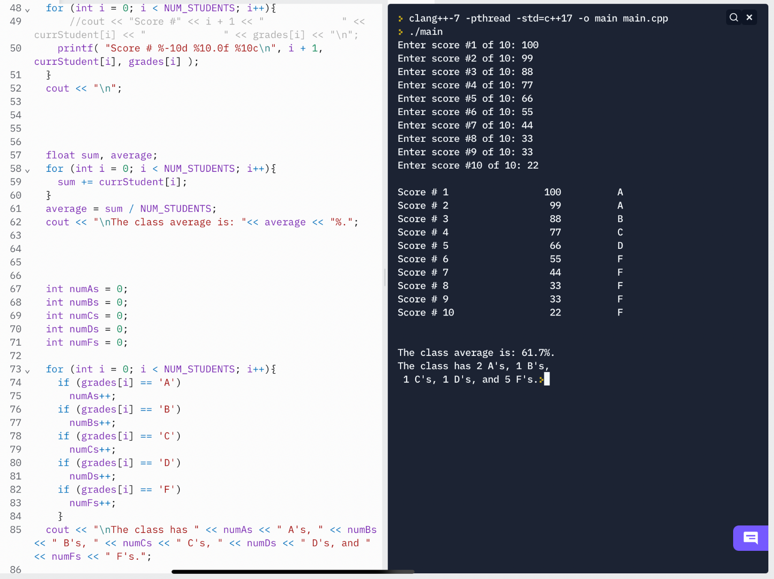

9b 10.6 Learn by Doing Exercises p 253 Break into 3 files: the main() file, the functions .cpp file and the .h file. 10 pts #1 Submit: code & runs

main() file:
#include "Scores.h"

int main() {

float currStudent[NUM_STUDENTS] {0.0};
char grades[NUM_STUDENTS];

ReadScores(currStudent);//note, no brackets when called--just like no ampersand when passing variables by ref.
LetterGrades(grades, currStudent);
PrintGrades(grades, currStudent);
Averages(currStudent);
GradeAmounts(grades);
}

Functions.cpp file:

#include "Scores.h"

void ReadScores(float currStudent[]){

for (int i = 0; i < NUM_STUDENTS; i++){

cout << "Enter score #" << i + 1 << " of " << NUM_STUDENTS << ": ";
cin >> currStudent[i];
}
cout << "\n";

}

void LetterGrades(char grades[], float currStudent[]){
for (int i = 0; i < NUM_STUDENTS; i++)
{
if ( currStudent[i] < 65.0 ){
grades[i] = 'F';
}
else if ( currStudent[i] < 75.0 ){
grades[i] = 'D';
}
else if ( currStudent[i] < 84.0 ){
grades[i] = 'C';
}
else if ( currStudent[i] < 92.0 ){
grades[i] = 'B';
}
else if ( currStudent[i] >= 92.0 ){
grades[i] = 'A';

}
}

}

void PrintGrades(char grades[], float currStudent[]){
for (int i = 0; i < NUM_STUDENTS; i++){
//cout << "Score #" << i + 1 << " " << currStudent[i] << " " << grades[i] << "\n";
printf( "Score # %-10d %10.0f %10c\n", i + 1, currStudent[i], grades[i] );
}
cout << "\n";

}

void Averages(float currStudent[]){
float sum, average;
for (int i = 0; i < NUM_STUDENTS; i++){
sum += currStudent[i];
}
average = sum / NUM_STUDENTS;
cout << "\nThe class average is: "<< average << "%.";

}

void GradeAmounts(char grades[]){
int numAs = 0;
int numBs = 0;
int numCs = 0;
int numDs = 0;
int numFs = 0;

for (int i = 0; i < NUM_STUDENTS; i++){
if (grades[i] == 'A')
numAs++;
if (grades[i] == 'B')
numBs++;
if (grades[i] == 'C')
numCs++;
if (grades[i] == 'D')
numDs++;
if (grades[i] == 'F')
numFs++;
}
cout << "\nThe class has " << numAs << " A's, " << numBs << " B's, " << numCs << " C's, " << numDs << " D's, and " << numFs << " F's.";

}

The .h file:

#include <iostream>
#include <stdio.h>

using namespace std;

const int NUM_STUDENTS = 10;

void ReadScores(float[]);
void LetterGrades(char[], float[]);
void PrintGrades(char[], float[]);
void Averages(float[]);
void GradeAmounts(char[]);

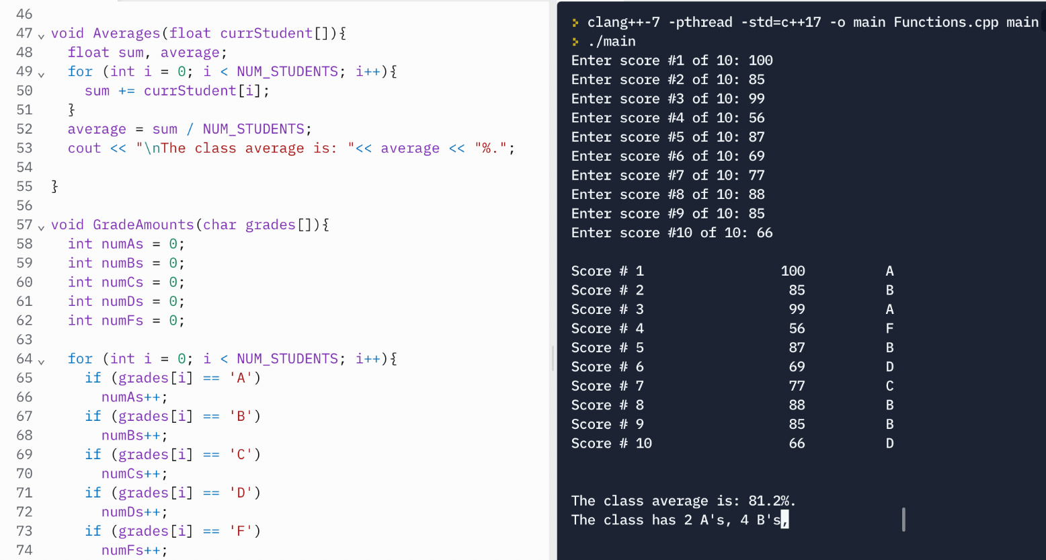

10a 10.7 Learn by Doing Exercises p 260 Break into at least 3 files as in 9b. 10 pts #2
Submit: code & runs

Names.h file:

#include <iostream>
using namespace std;
using std::cout;
using std::cin;

void GetFirstName(char[]);
void GetLastName(char[]);
void CombineNames(char[], char[], char[]);
void PrintName(char[]);

Main.cpp file:

#include "Names.h"

int main() {

char firstname[20]{};
char lastname[20]{};
char fullname[42]{};
GetFirstName(firstname);
GetLastName(lastname);
CombineNames(firstname, lastname, fullname);
PrintName(fullname);

}

Functions.cpp file:

#include "Names.h"

void GetFirstName(char firstname[]){
cout << "Enter your first name: ";
cin >> firstname;
}

void GetLastName(char lastname[]){
cout << "Enter your last name: ";
cin >> lastname;
}

void CombineNames(char firstname[], char lastname[], char fullname[]){
int i = 0;
int l = 0;

for (i = 0; lastname[i] != '\0'; i++){
fullname[i] = lastname[i];
l = i;
}

l += 1;

fullname[l++] = ',';
fullname[l++] = ' ';

for (i = 0; firstname[i] != '\0'; i++){
fullname[l++] = firstname[i];

}

fullname[l++] = '\0';

for (l = 0; l != '\0'; l++){

cout << fullname[l];
}
}

void PrintName(char fullname[]){

cout << "\nYour full name is: ";

int i = 0;

while ( fullname[i] != '\0' ){
cout << fullname[i];
i++;
}
}

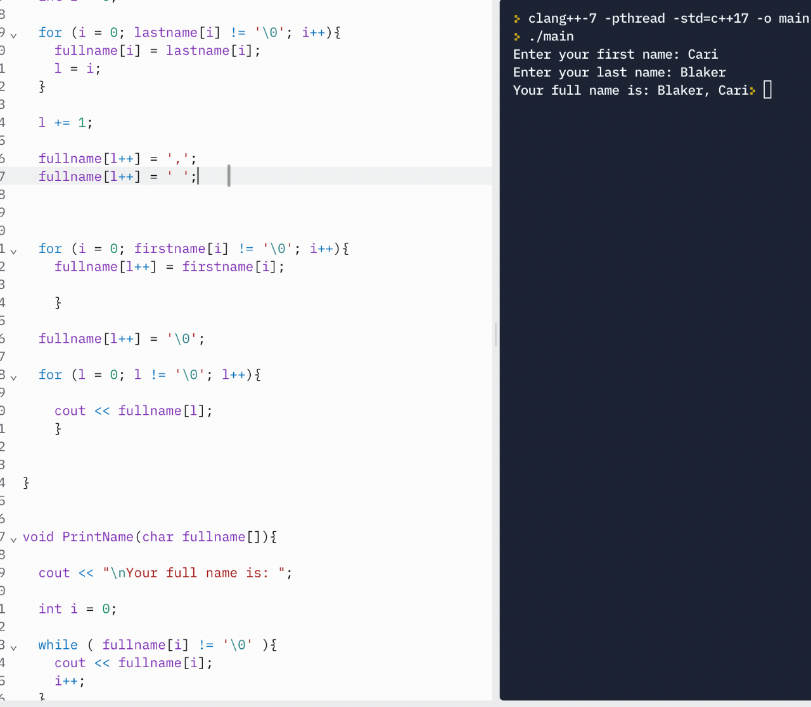
10b 10.8 Learn by Doing Exercises p 273 Break into at least 3 files as in 9b. 10 pts #7 Write a full program to do this. Submit: code & runs Total: 40 pts

Strings.h file:

#include <iostream>
using namespace std;

void CompareStrings(char[], char[]);

Main.cpp file:

#include "Strings.h"

int main() {

char string_1[] = "Frank";
char string_2[] = "Franklyn";

CompareStrings(string_1, string_2);
}

functions .cpp file:

#include "Strings.h"

void CompareStrings(char string_1[], char string_2[]){
int i = 0;
int count = 0;

for ( i = 0; string_1[i] == string_2[i]; i++){
count++;
}

if ( count >= 6 ){
cout << "Same.";
}
else
cout << "Different.";
}
