CST116

Module 3: Lab 3

5a

6.4 Exercises

p 126

5 pts #1

Submit: output

- a = 0; no display, a = 0
cout << a++ << endl; displays a = 0, a value = 1
cout << ++a << endl; displays a = 2, a value = 2
cout << a + 1 << endl; displays a = 3, a value = 3
cout << a << endl; displays a = 3, a value = 3
cout << --a << endl; displays a = 2, a value = 2

7.1 Exercises

p 148

5 pts #1-6

Submit: corrected conditions

- int_exp1 => int_exp2 the operator needs to be written >=
- int_exp1 = int_exp2 = is the assignment operator. Needs to be ==
- int_exp1 =! int_exp2 =! needs to be written !=
- char_exp == “A” “A” needs to be written ‘A’
- int_exp1 > char_exp cannot compare a number with a character
- int_exp1 < 2 && > -10

7.2 Learn by Doing Exercises

p 155

10 pts #1

Submit: code & run

Total: 15 pts

#include <iostream> <iomanip>

using std::cout;
using std::cin;
using std::endl;

int main()
{
short choice;

cout << "\t\t\tStudent Grade Program";
cout << "\n\t\t\t - Main Menu -";
cout << "\n\n\t\t1. Enter Name";
cout << "\n\t\t2. Enter test scores";
cout << "\n\t\t3. Display test scores";
cout << "\n\t\t9. Exit";
cout << "\n\n\tPlease enter your choice from the list above: ";

cin >> choice;

switch (choice)
{
case 1:
cout << "\n\tYou chose: Enter name" << endl;
break;
case 2:
cout << "\n\tYou chose: Enter test scores" << endl;
break;
case 3:
cout << "\n\tYou chose: Display test scores" << endl;
break;
case 9:
cout << "\n\tYou chose: Exit" << endl;
break;
default:
cout << "\n\tMenu choice does not exist" << endl;

}

return 0;
}

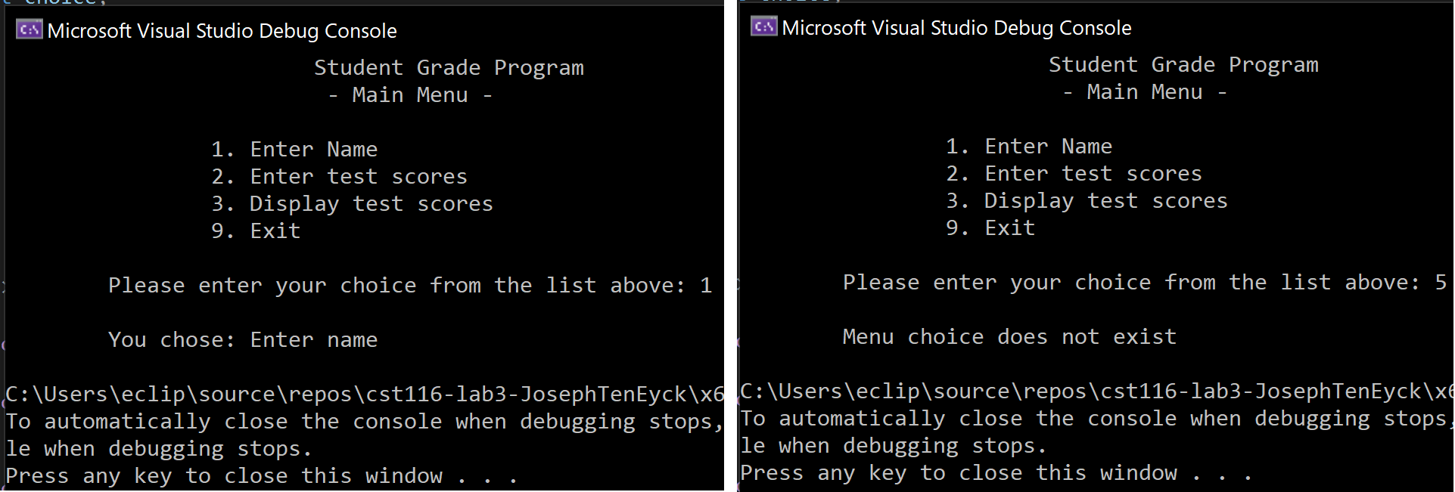

5b

7.4 Learn by Doing Exercises

p 161

10 pts #1

Submit: code & run
SEE .cpp file for code and text file for runs.

5c

7.10 Programming Exercises

p 168

10 pts #2

Submit: code & run

- Determine if a loan is legitimate then display the fees for a loan.
- PSEUDOCODE
- DECLARE variables for interest rate, loan amount, total cost.
  - IF interest rate is outside of 1% to 18% range OR loan amount is outside of $100 to $1,000 dollars
  - THEN display error message
  - OTHERWISE proceed

  - IF loan amount is $100 to $500, fee amount = $20
  - IF loan amount is greater than $500, fee amount = $25
- Calculate interest paid and total cost.
- Display loan amount, interest rate, fee, amount of interest, and total cost.

SEE .cpp file for code and text file for runs.

6a

6.5 Exercises

pp 126-127

3 pts #1-5

Submit: converted statements

- a = 25 + a; CORRECTED: a += 25;
- b = b * a * 2; CORRECTED: b *= (a * 2);
- b = 1 + b ; CORRECTED: b = ++b;
- c = c % 5; CORRECTED: c %= 5;
- b = b / a; CORRECTED: b /= a;

8.2 Learn by Doing Exercises

pp 177

10 pts #1

Submit: code & run

SEE .cpp file for code and text file for runs.

8.3 Learn by Doing Exercises

pp 179

10 pts #1

Submit: code & run

SEE .cpp file for code and text file for runs.

6b

8.4 Learn by Doing Exercises

p 184

10 pts #1

Submit: code & run

SEE .cpp file for code and text file for runs.

6c

8.10 Programming Exercises

p 192

10 pts #3

Submit: code & run
SEE .cpp file for code and text file for runs.

