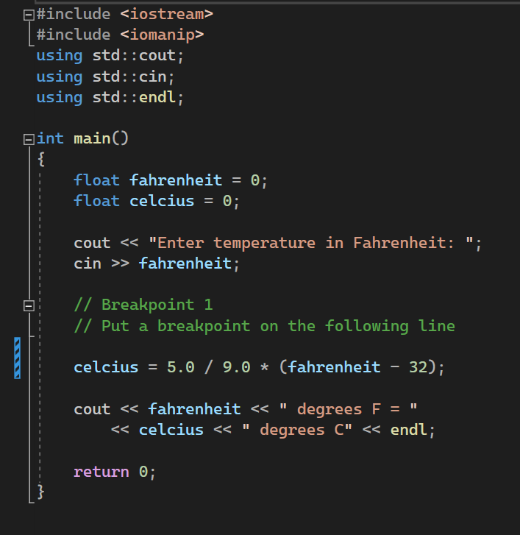
Output for Ch 6 Debugging
Enter temperature in Fahrenheit: 212
212 degrees F = 100 degrees C

C:\Users\matth\Source\Repos\cst116-ch6-debugging-matthewtaeza\CST116-Ch6-Debugging\x64\Debug\CST116-Ch6-Debugging.exe (process 18364) exited with code 0.
Press any key to close this window . . .

Output for Ch 5 Debugging

